Instructions before the translation:
- Maintain same formatting
- Place your translation on the next page under “Your Translation”

ESPRESSO COFFEE MACHINE

HYDRAULIC CONNECTION FOR EPU - EVD - EVDT MACHINES
- Remove any rubber plugs which may be inserted in the tap fixtures of the softener.
- Connect the water mains (2) to the softener inlet (7) using the provided hose.
- rinse resins from the softener and check that the water, which initially comes out yellowish, comes out clean
- connect the softener outlet (8) to the external motor pump inlet (9);
- connect the outlet of the motor pump (10) to the inlet of the machine (11);
- connect the drain tub of the machine (12) to the sewer discharge (13) using the special tube provided. Take care to avoid overly tight bends or kinks, and make sure that there is sufficient inclination for water to flow out of the drain.
HYDRAULIC CONNECTION OF ALE MACHINES
- Remove any rubber plugs which may be inserted in the tap fixtures of the softener.
- connect the water mains (2) to the inlet of the machine (11);
- connect the drain tub of the machine (12) to the sewer discharge (13) using the special tube provided. Take care to avoid overly tight bends or kinks, and make sure that there is sufficient inclination for water to flow out of the drain.
NOTE
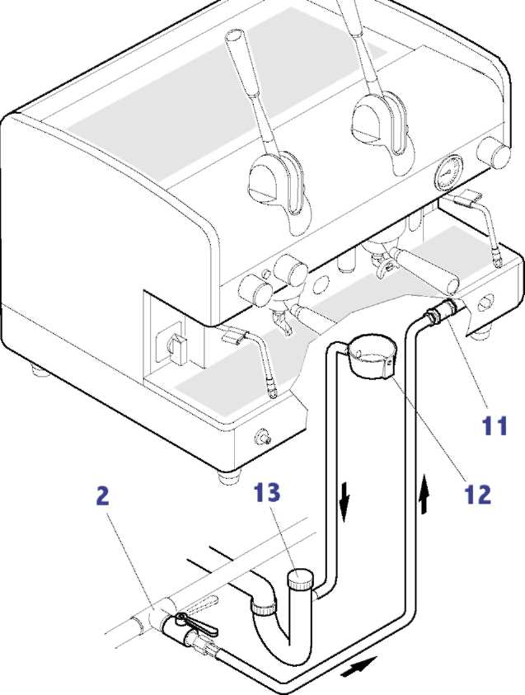
All filling connections are 3/8 male gas type. The drain tub is connected with a tube with an internal diameter of 16mm.
Warnings
- The water mains must provide cold water for human consumption (potable water) at a pressure between 1 and 5 bar inclusive. If the pressure is greater than 5 bar, connect a pressure reducer upstream from the pump.

YOUR TRANSLATION

